Date: September 20, 2018

To: S. Freeman, Professor, Northeastern University

From: R. Persaud, O. Litus, G. Bruce, Northeastern University

Re: Summary of Programming Experience and Questions

**Introduction**

Robots are defined as “a machine capable of carrying out a complex series of actions automatically, especially one programmable by a computer”. But, what about a robot that was eco-friendly and small? Microbots today face a challenge of finding a new power source for a self-sustainable working cycle. Well, that’s when we cue the entrance of hygrobots. Hygrobots are described to be “a biologically inspired bilayer structure that harnesses the environmental humidity energy, with ratchets to rectify the motion” *(Science Robotics 24 Jan 2018).*

**Summary**

Everyone and everything has a trigger or per say invigorating inspiration that spurs the creation of an idea or thought. The ordeal of hygrobots was formulated by the ideals of plants. Plants go through hygroexpansion - attracting and holding water molecules from the surrounding environment, which can change shape and size. This phenomenon was the basis of hygrobots. It is very simple. Water transport of fluid (mostly water) in and out of the plant tissue generates motions. For instance, “pine cones close when it’s wet, and open when it’s dry so that the seeds inside them can disperse farther away” *(Science Robotics 24 Jan 2018)*. Scientists believed they could apply this very logic to robots. As of right now, Seoul University created an “inchworm” that appears to be for now only crawling and wriggling around. However, this little stepping block will be the pioneering tool used to form a biomedical treatment on the skin such as delivering drugs *(Science Robotics 24 Jan 2018)*. 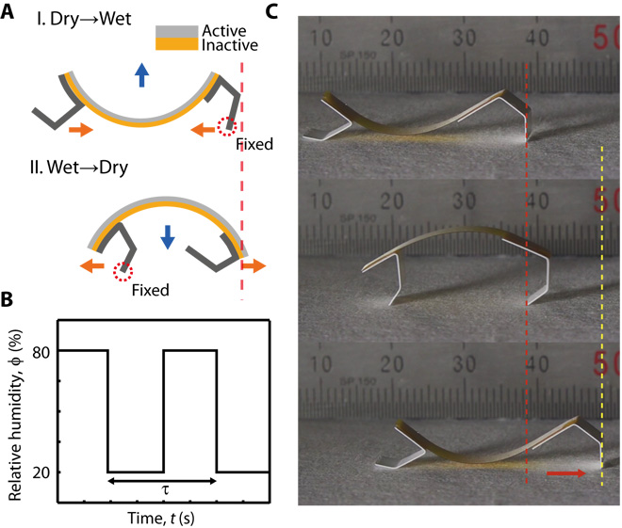

Hygrobots are created out of two layers made of nanofibers. The active layer can “swell rapidly in response to the directionality, or amount, of humidity in its immediate vicinity” allowing the hygrobot to jump upwards. The second layer in the meantime manages the motion of the strip to move forward *(Science Robotics 24 Jan 2018)*. Humidity comes into the picture when the robot is placed on a wet surface, one layer sucks the humidity in, allowing the robot to shoot into the air. After this event, the layer dries which allows for the robot to return to the surface, allowing for the cycle to repeat *(Science Robotics 24 Jan 2018)*.

*(*[*http://robotics.sciencemag.org/content/3/14/eaar2629*](http://robotics.sciencemag.org/content/3/14/eaar2629)*)*

**Conclusion**

Hygrobots has the potential with the use of natural power input be widely used in medical, military, and industrial applications. Hygrobots could potentially be used for medical uses on wet skin or even sterilization of medical equipment. This product is highly progressive for experiments and has shown that “hygrobot soaked in antibiotics could inch across a culture plate filled with bacteria, leaving behind a sterilized trail, a bit like a slug would leave a trail of slime in its wake”*(Science Robotics 24 Jan 2018)*. The study shows promise for the new bot to be used in lots of biomedical applications. Options are also endless with the start of a singular robotic inchworm.

**Citations**

1. Science Robotics 24 Jan 2018: Vol. 3, Issue 14, eaar2629 DOI: 10.1126/scirobotics.aar2629 <http://robotics.sciencemag.org/content/3/14/eaar2629>

**Hygrobot: A self-locomotive ratcheted actuator**

**powered by environmental humidity**

1. <http://www.msrl.ethz.ch/content/dam/ethz/special-interest/mavt/robotics-n-intelligent-systems/multiscaleroboticlab-dam/documents/Publications/ICRA14_1224_Fusco.pdf>
2. <https://www.theverge.com/2018/1/26/16932662/hygrobot-micro-robots-air-moisture-plants>
3. <https://www.insidescience.org/news/brief-plant-inspired-robots-inch-forward-absorbing-and-releasing-water>
4. <https://techxplore.com/news/2018-01-tiny-hygrobots-batteriesthey-powered.html>

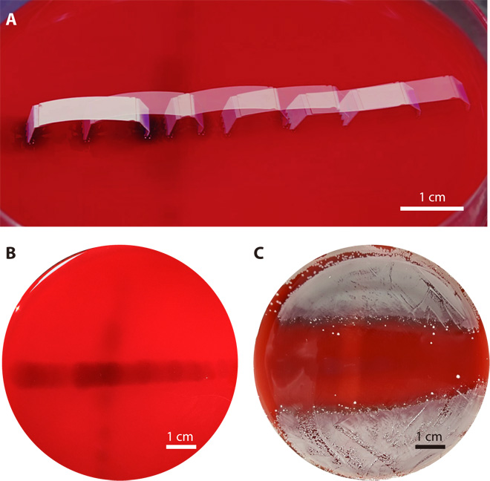

**Ol…**

**Links**

1. Science Magazine Research paper <http://robotics.sciencemag.org/content/3/14/eaar2629>
2. Original post at Popular Mechanics <https://www.popularmechanics.com/technology/robots/a15913436/moisture-powered-inchworm-robot/>
3. Other cool robor! You can eat it <https://www.popularmechanics.com/technology/robots/news/a28558/researchers-create-edible-robotic-actuators/>
4. <https://arxiv.org/pdf/1703.01423.pdf>
5. <https://spectrum.ieee.org/automaton/robotics/robotics-hardware/an-edible-actuator-for-ingestible-robots>

Cool/Interesting/important facts and ideas:

* Other than responding only to water vapor, researchers say they could equip them with sensors that respond to other gases as well. - we can create robots that will work on other planets without water vapor in extreme gases, where other robots with motors would not.
* Shapeshifting microrobots for Medicine <https://pubs.acs.org/doi/abs/10.1021/acsami.5b00181>
* Create the same robots, but that will react to the difference in concentration in the liquid
* Self-folding microbots <http://www.msrl.ethz.ch/content/dam/ethz/special-interest/mavt/robotics-n-intelligent-systems/multiscaleroboticlab-dam/documents/Publications/ICRA14_1224_Fusco.pdf>
* How paper bends with humidity <https://www.seas.harvard.edu/softmat/downloads/2014-16.pdf>